TITLE OF ABSTRACT (Centered, 14 Points, Bold)

A. LastName1, B. LastName1, C. LastName2

1University, Department, Mailing address, [author1@company.net](mailto:corresponding.author@company.net)

2Company, Mailing address, [author2@company.net](mailto:author2@company.net)

# ABSTRACT (Centered, 12 Points, Bold)

Place here your **maximum 1 page abstract**. Use 11 point Times New Roman (Normal Style). The abstract should summarize the context of the presentation. It will be published in the book of abstracts.

Graphs, figures and tables must have a caption. Captions should be centered at the foot of the figure and typed in the same 11 point font used in the paper. References should be noted with square brackets [1] and figures with “fig.1”.

Please send the abstract in **PDF format** at mcaccamo@unime.it by **9th December 2024**.

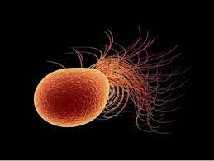

Figure 1: Example of a figure.

# REFERENCES (Centered, 12 Points, Bold)

1. M.T. Caccamo, C. Gugliandolo, V. Zammuto, S. Magazù, “Thermal properties of an exopolysaccharide produced by a marine thermotolerant Bacillus licheniformis by ATR-FTIR spectroscopy”, International Journal of Biological Macromolecules, 145, 77-83, 2020, <https://doi.org/10.1016/j.ijbiomac.2019.12.163>

Oral contribution

Poster contribution